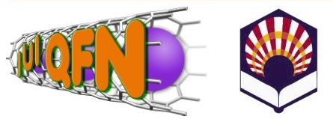
NANOUCO VII
Encuentro sobre Nanociencia y Nanotecnología de Investigadores Andaluces
Córdoba, 21 y 22 de enero de 2019


REGISTRATION FORM
Name:
Family Name:
Professional address:

Phone:
e-mail:

Fee
Before 15/01/2019 After 15/01/2019

General 60 € General 80 €

Student* Free if at least one of the senior researchers are registered.

Senior researcher registered: _
* Include student accreditation
**Payment
- Researcher from UCO
Internal transference to UG: 600461
-Researcher from other universities or centres.
Bank transference to a la Universidad de Córdoba: IBAN: ES77-0049-2420-31–2714626725
Recipiento: Universidad de Córdoba
Concept: Inscripción de < Name, family Name> a NANOUCO – VII Workshop

Send the document accrediting the payment

NANOUCO VII (Administración)
José Manuel Membrives Obrero
Departamento de Química Analítica (Edif. Marie Curie, Anexo, 3ª planta)
Campus Universitario de Rabanales, 14071- Córdoba (España)
Tlf. y Fax de contacto: 34 957 218616
e-mail: nanouco.administracion@uco.es

